Adhem Azzabi

Professor Laura

CIS 164

January 1, 2020

**1. Create Your Virtual Machine (Preparation/Creation)**

1. 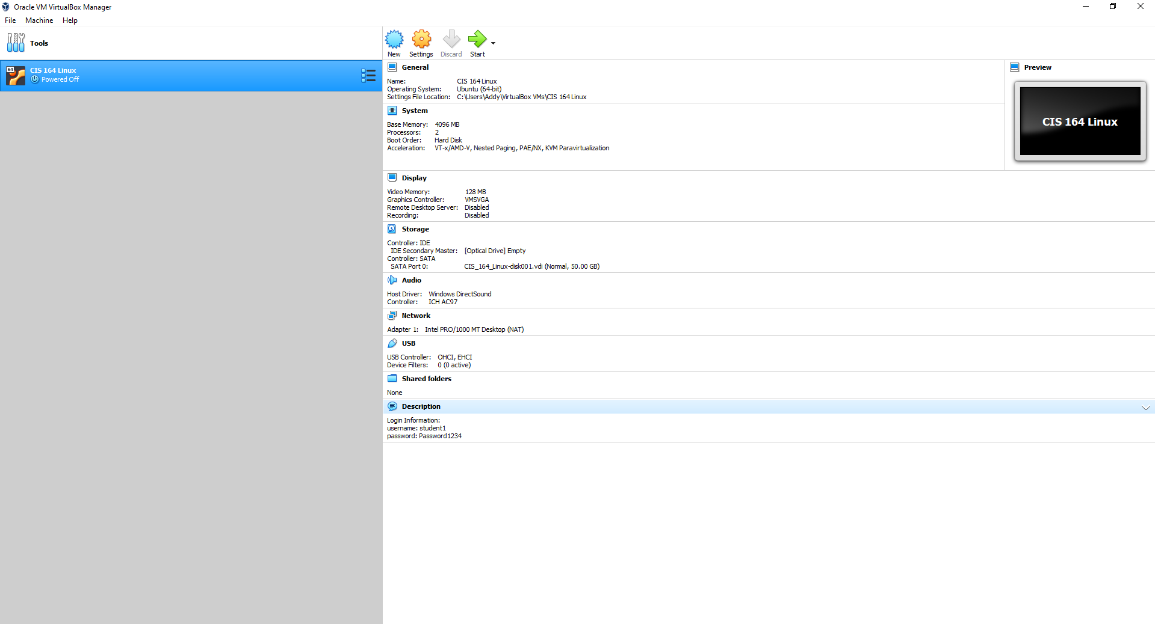
2. 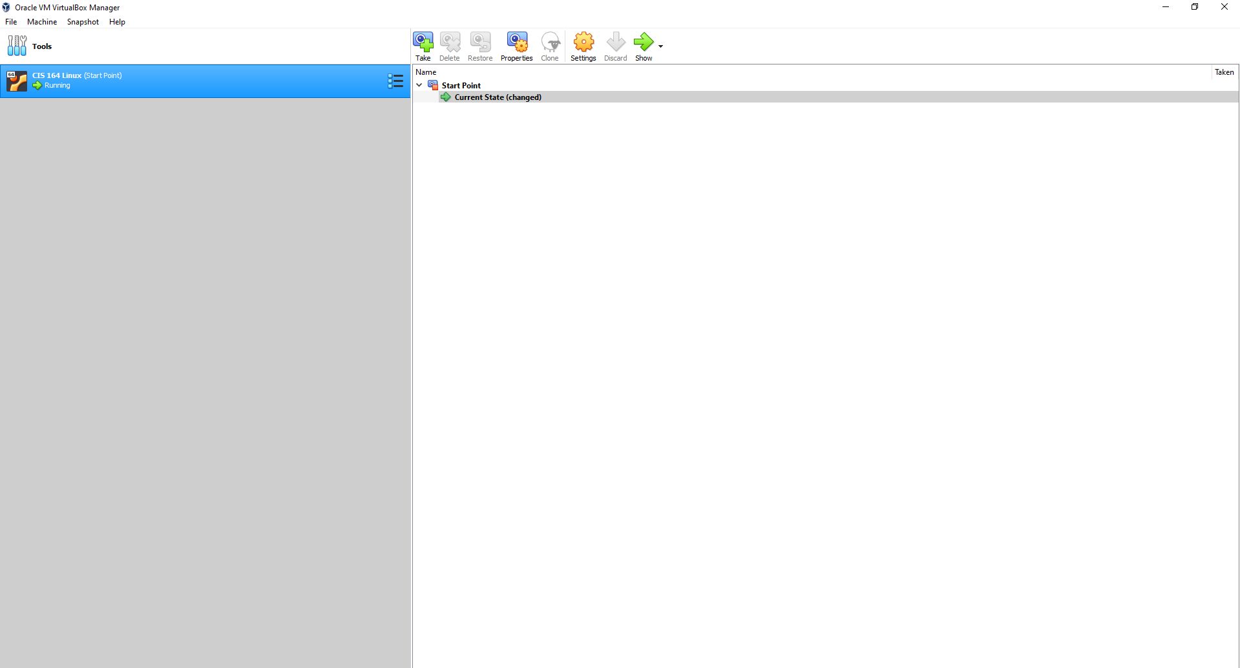
3. 